Information within this document includes an Introduction, Overview, Getting There, Entry, Experiences, Dining, Amenities, Sensory Guide, Contacts, Communication Board

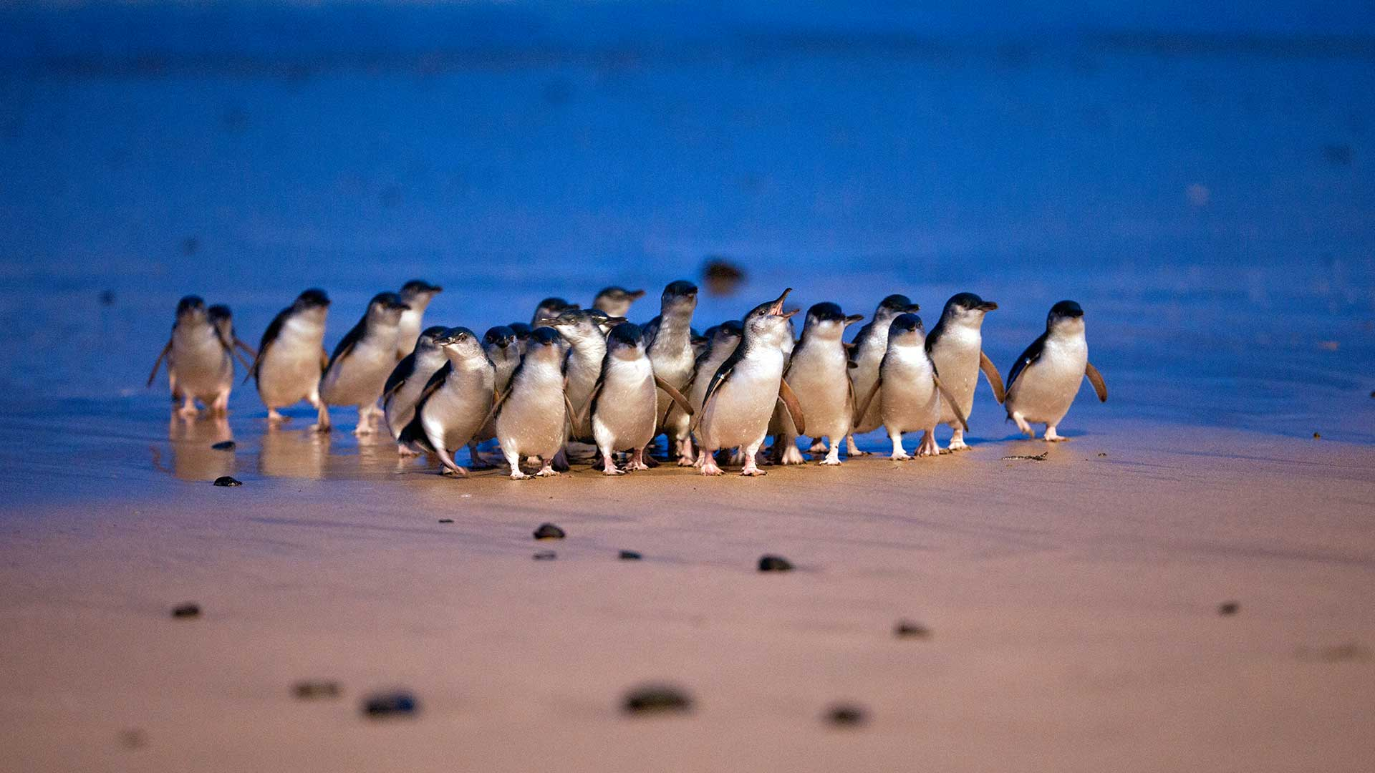

# Introduction

Phillip Island is home to the largest Little Penguin colony in the world. You can experience the magic of watching these amazing seabirds waddle home from the ocean to their burrows any night of the year from our viewing platforms and boardwalks.

The Penguin Parade offers easy access and is a certified sensory-inclusive site with professionally trained staff.

This is a ticketed experience, and everyone aged 4 years and over requires a ticket to attend. Companion and Carer cards are recognised, and concessions do apply for card holders. Details in the Entry section of this document.

The visitor centre opens a couple of hours before sunset when the penguins are due to arrive at the beach. It opens at approximately 4pm in winter months and 5pm in summer months. For up to date times check our website [Penguin Parade » Phillip Island Nature Parks (penguins.org.au)](https://www.penguins.org.au/attractions/penguin-parade/)

If you are planning a visit from mid-December to late January, or during a long weekend or school holiday period, please allow extra travel time as the traffic can get busy. Be sure to pre-book your tickets to avoid missing out as we do sell out during peak periods. Please arrive at recommended time shown on the ticket as seating is limited and not guaranteed. Standing space is available.

# Overview

The Penguin Parade is made up of indoor and outdoor attractions. There is one access point which is the visitor centre.

|  |
| --- |
|  |
| *Ticketing Counter with low height section* |

|  |
| --- |
|  |
| *Path with gentle gradient to main entrance* |

The designated accessible parking spaces are approximately 200 metres from the entrance. The path to the entrance is generally flat with one section that is a gentle rise. Gradients throughout the rest of the area are generally flat. There are some steep sections to access the penguin viewing area.

The visitor centre incorporates a ticketing area, a restaurant and separate cafe, souvenir shop, theatre, and interpretive displays.

The souvenir shop is well laid out with wide aisles and most stock within easy reach.

There is a complimentary wheelchair available for use.

There is a complimentary buggy service if transport to the beach is required. Ask at the back doors.

There are wheelchair access viewing areas in the General Viewing, Penguins Plus and Underground Viewing areas.

Visitors who use assistance animals certified by a registered authority are welcome. Assistance animals must remain on designated paths and restrained by a harness or lead at all times.

|  |
| --- |
|  |
| *Wide spaces between display in Souvenir Shop* |

An assisted listening service is available in the Theatre. Receivers are available at no cost. Ask staff at the ticketing counter when you arrive.

For visitors with sensory needs, sensory bags are available, equipped with noise-cancelling headphones, fidget tools and verbal cue cards. Weighted lap pads are also available.

These are available for free by leaving ID with staff at the visitor centre.

In the event of evacuation trained team members will direct guests toward the safest exit points.

# Getting there

|  |
| --- |
|  |
| *Four Designated Accessible Parking Bays* |

**By car:** Phillip Island is located 90 minutes’ drive from Melbourne. Allow a further 20 minutes from the bridge to get to the Penguin Parade. There is free parking on site, including four designated accessible parking bays.

**By bus:** Public transport is limited on Phillip Island. V-line operates a bus to Phillip Island’s main town, Cowes, from Southern Cross Station in Melbourne city. The V-line bus does not go to the Penguin Parade and there are no return buses to Melbourne at the conclusion of the Penguin Parade. If you travel to Phillip Island by bus, you will need to arrange accommodation.

**By taxi:** Contact Phillip Island Taxis on 03 5952 2200 to arrange transfers on Phillip Island.

**Tours and Transport:** Contact a Visitor Information Centre in Melbourne or on Phillip Island for tours and transport options.

# Entry

Online booking is available on the [Phillip Island Nature Parks website](https://bookings.penguins.org.au/BookingCat/Availability/?ParentCategory=WAF-WEBSITE).   
Discounts are available for holders of Australian pensioner cards, seniors cards, carer cards and   
DVA gold cards.

Companion card holders are free of charge but must book their ticket by phoning 03 5951 2830.

All cards must be shown on arrival.

# Experiences

The Penguin Parade offers a variety of activities suitable for all ages and abilities. Whether you’re looking for a self-guided experience or to be led by one of our knowledgeable rangers, we have an option for you.

**General Viewing** - There is tiered seating in the general viewing grandstands. They overlook the picturesque Summerlands Beach. The access to this area is via a steep ramp. There is allocated space at the top of the grandstand for wheelchairs with a limited number of seats. The grandstand seating is timber and there are grabrails for support to access the lower levels. A nightly stand talk by Rangers is provided and Sensory bags are available from the rangers at this location.

**Penguins Plus** – This area allows for a closer viewing experience, also with tiered seating. A nightly stand talk by rangers is provided.

**Underground Viewing** – This is an underground area where you can watch the Little Penguins waddle right past the window, some might even come up to the glass to say g’day. This area has ramp access and a nightly stand talk by rangers is provided.

|  |  |
| --- | --- |
|  |  |
| *General Viewing Area* | *Seating in the General Viewing Area* |

Some areas of the Penguin Parade can get a little loud. There are Quiet Zones and Headphone Zones around the viewing areas. They are clearly marked, but you can also ask a staff member for directions.

|  |  |
| --- | --- |
|  |  |
| *Quiet Zone Sign* | *Headphone Zone Sign* |

Penguins arrive at different times during the year. Times are shown below and are available on the website [Penguin-Calendar.pdf (penguins.org.au)](https://www.penguins.org.au/assets/Penguin-Parade/Penguin-Information-Calendar.pdf)

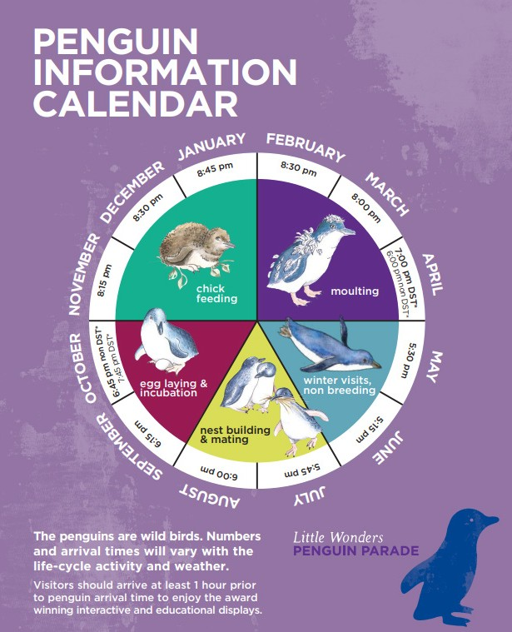

**Inside the visitor centre is The Habitat.**

It is an interactive area with educational opportunities where you can learn about penguins, their neighbours and the environment they live in. Pictures below.

This area can get a little loud too, so it’s also listed as a Headphone Zone.

|  |  |
| --- | --- |
|  |  |
|  |  |

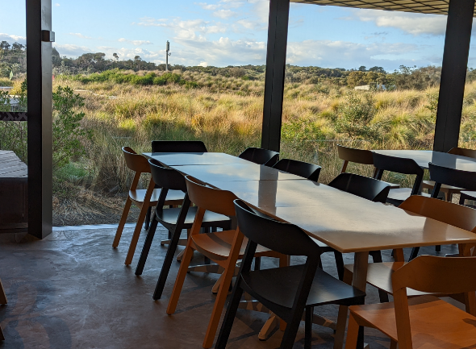

# Dining

There are two options for eateries in the visitor centre. They are the Little Penguin Café or the Shearwater Restaurant.

Opening hours for the café and restaurant vary throughout the year.

Order your food from the counter and you will be given a buzzer to let you know when it is ready. Vegetarian and gluten free options are available.

There is a range of seating in both areas. Some seating has views to the outside. Chairs are easily moved to allow wheelchair access.

|  |
| --- |
|  |
| *Changing Places Sign* |

# Amenities

There are multiple unisex accessible toilets outside the entrance and inside the visitor centre.

There is a Changing Places facility inside the visitor centre.

There are male and female ambulant toilets inside the visitor centre.

There are toilets located midway to the penguin viewing area, although they are not accessible.

# Sensory Guide

We are a certified sensory-inclusive site with professionally trained staff. Sensory bags are available, equipped with noise-cancelling headphones, fidget tools and verbal cue cards. Weighted lap pads are available. The bags and lap pads can be checked out for free by leaving an ID with our staff.

There are Headphone Zones and Designated Quiet Areas in the visitor centre. While at the Penguin Parade you may experience:

|  |  |  |  |
| --- | --- | --- | --- |
| **Feel** | **Sounds** | **Sights** | **Smells** |
| Different ground surfaces | People | Bright lights and glare | Disinfectants |
| Shared personal space | Audio presentations | Reflections | Nature |
| Weather; wind, rain | Penguins and birds | Penguins and birds | Strong animal smells |
| Sea spray | Animals | Animals |  |
|  | Wind | Ocean and beach |  |
|  | Ocean | Trees and plants |  |
|  |  | People, some in groups |  |
|  |  | Buggy |  |

# Contacts

Penguin Parade

1019 Ventnor Road

Summerlands VIC 3922

[www.penguins.org.au](http://www.penguins.org.au/)

[Accessibility Statement](https://www.penguins.org.au/attractions/penguin-parade/)

# Communication Board

You can print and take this Communication Board with you when you visit the Penguin Parade.

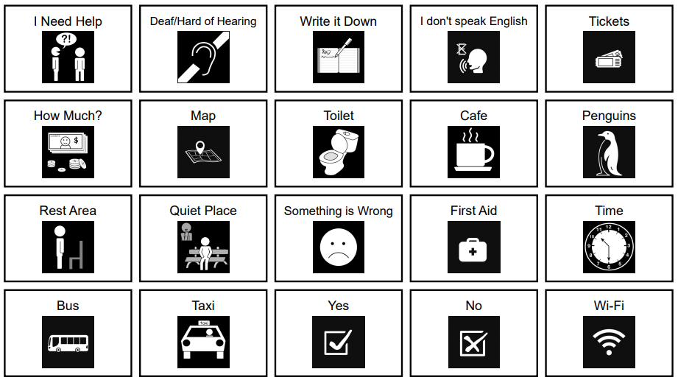

© Inclusive Tourism Pty Ltd, All Rights Reserved. 2022 Owned and developed by Inclusive Tourism Pty Ltd www.InclusiveTourism.com.au