Phillip Island Nature Parks is committed to offering enjoyable nature-based experiences and has a range of accessible facilities available for all visitors. This following information aims to accurately describe the facilities and services that are offered at the Penguin Parade.
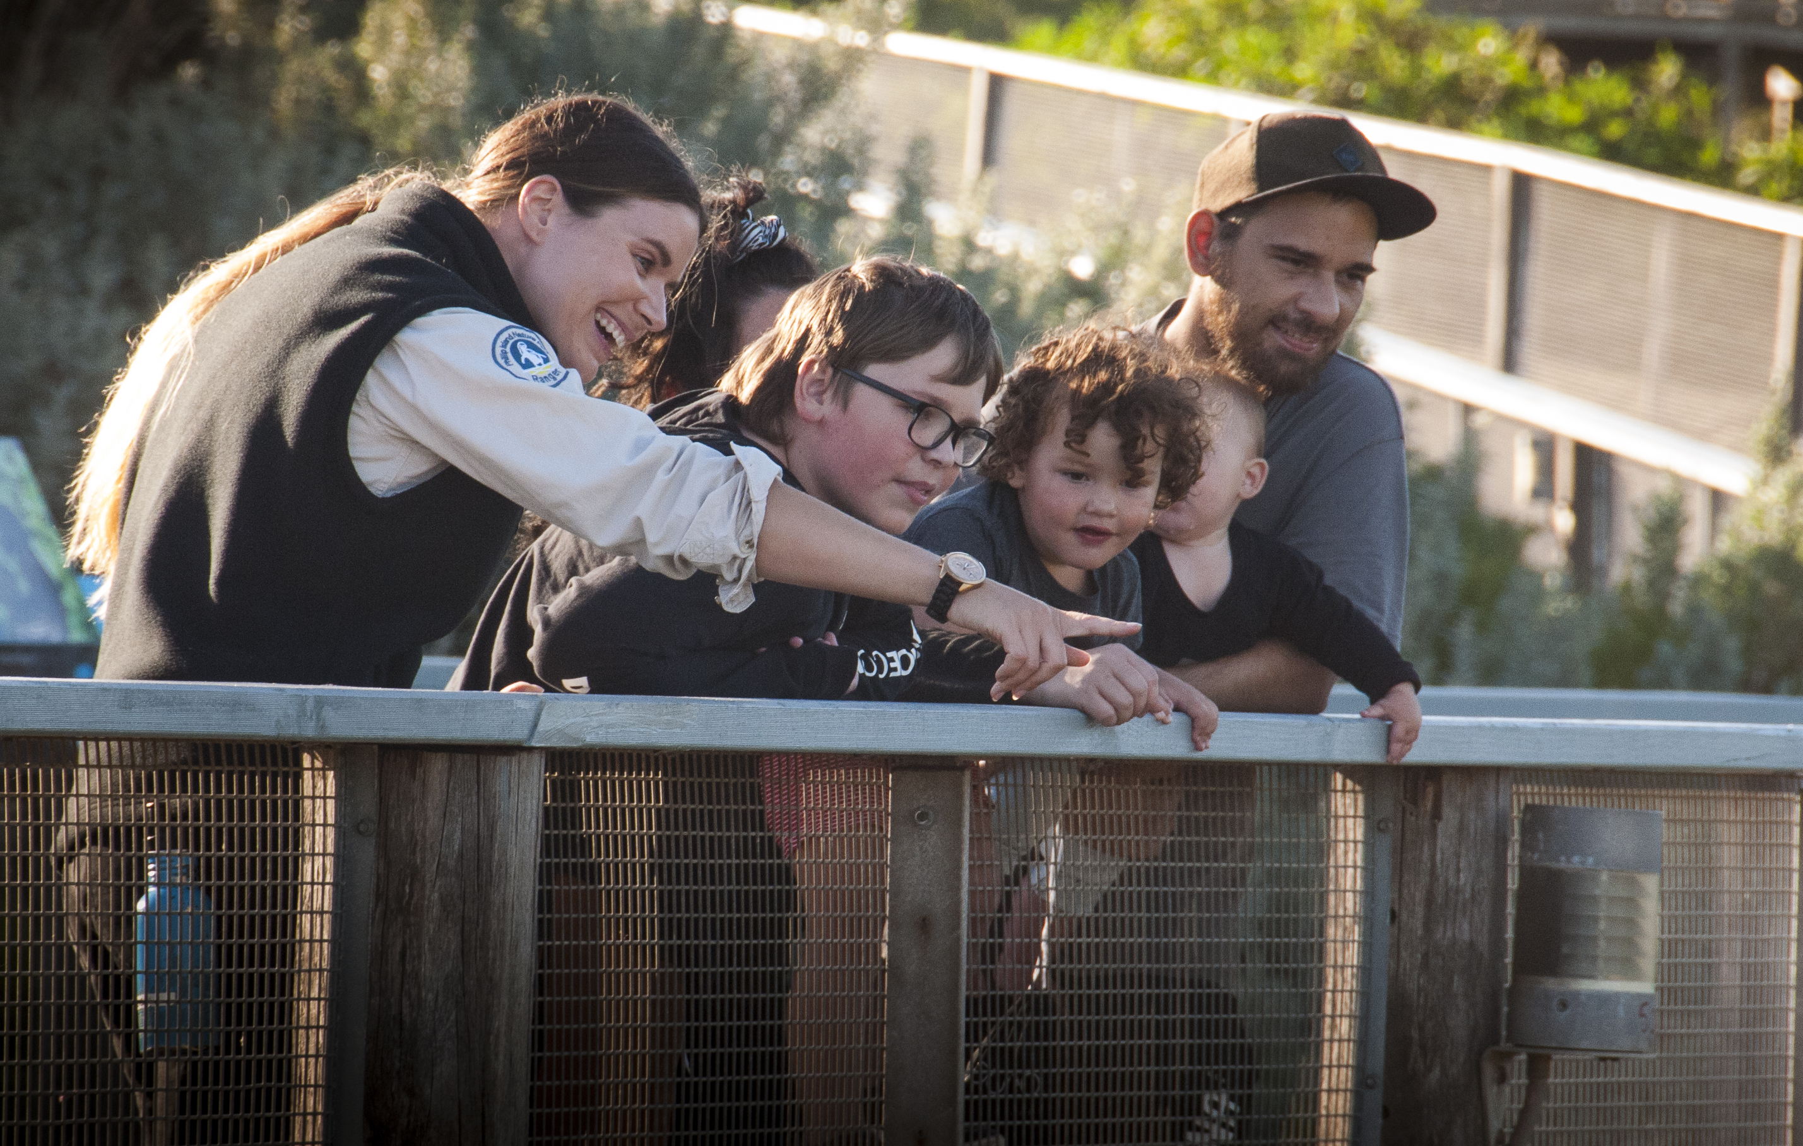

Penguin Parade staff engaging with visitors
PRE-ARRIVAL INFORMATION
The Penguin Parade is made up of indoor and outdoor attractions. The Penguin Parade Visitor Centre is the main access point to the attractions. The Penguin Parade offers easy access and is a certified sensory-inclusive site with professionally trained staff.
Ticketing
The visitor centre opens a couple of hours before sunset when the penguins are due to arrive at the beach. It opens at approximately 4 pm in winter months and 6 pm in summer months. For up-to-date times check our website Phillip Island Opening Times | Phillip Island Nature Parks
If you are planning a visit from mid-December to late January, or during a long weekend or school holiday period, please allow extra travel time as the traffic can get busy. Be sure to pre-book your tickets to avoid missing out as we do sell out during peak periods. Please arrive at recommended time shown on the ticket as seating is limited and not guaranteed. Standing space is available.

Carparking
Phillip Island is located 90 minutes drive from Melbourne. Allow a further 20 minutes from the bridge to get to the Penguin Parade. There is free parking on site, including four designated accessible parking bays.
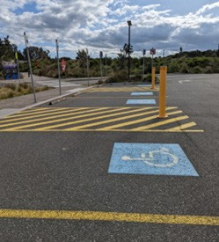
Four designated accessible parking bays
The designated accessible parking spaces are approximately 200 metres from the Penguin Parade Visitor Centre entrance. The path to the entrance is generally flat with one section that is a gentle rise. Gradients throughout the rest of the area are generally flat.
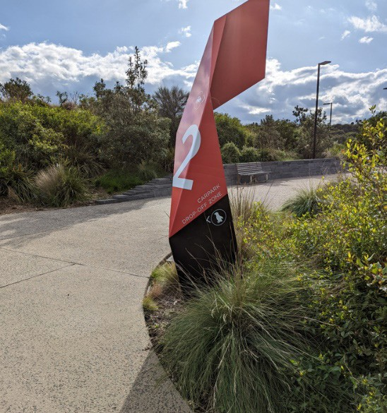
Path with gentle gradient to main entrance

ARRIVAL INFORMATION
Companion Card Holders
Discounts are available for holders of Australian pensioner cards, senior’s cards, carer cards and DVA gold cards. The card holder’s companion will be issued with a ticket at no charge to all Phillip Island Nature Parks attractions. Equivalent overseas cards are also valid. Entry for card holder is applicable adult, child or concession entry.
 | 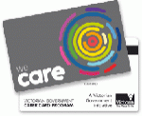
Visitors with a Victorian Carers Card are entitled to entry at the pensioner rate to all Phillip Island Nature Parks. All cards must be shown on arrival.

Reduced Mobility
There are complimentary wheelchairs available for use. Ask the friendly staff at the ticketing desk.
There is a complimentary buggy service if transport is required to the viewing areas. Ask staff at the ticket turnstiles as you approach the boardwalks.
There are wheelchair access viewing areas in the General Viewing, Penguins Premium, Penguins Plus and Underground Viewing areas.

Assistance Dogs
Visitors who use assistance animals certified by a registered authority are welcome. Assistance animals must remain on designated paths and always restrained by a harness or lead.

Sensory Guide
We are a certified sensory-inclusive site with professionally trained staff. Sensory bags are available, equipped with noise-cancelling headphones, fidget tools and verbal cue cards. Weighted lap pads are available. The bags and lap pads can be checked out for free by leaving an ID with our staff.
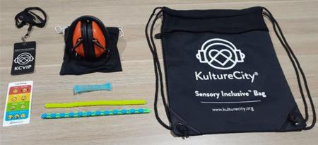
Sensory bags inclusions
There are Headphone Zones and designated quiet areas in the visitor centre. While at the Penguin Parade you may experience:
Feel | Sounds | Sights | Smells
Different ground surfaces | People | Bright lights and glare | Disinfectants
Shared personal space | Audio presentations | Reflections | Nature
Weather; wind, rain | Penguins and birds | Penguins and birds | Strong animal smells
Sea spray | Animals | Animals
 | Wind | Ocean and beach
 | Ocean | Trees and plants
 |  | People, some in groups
 |  | Buggy

Social Scripts
The Penguin Parade is a KultureCity certified sensory inclusive venue. The social story is available here KultureCity - Venue

THE VISITOR CENTRE
The visitor centre incorporates a ticketing area, a restaurant and separate cafe, souvenir shop, theatre, and interpretive displays.
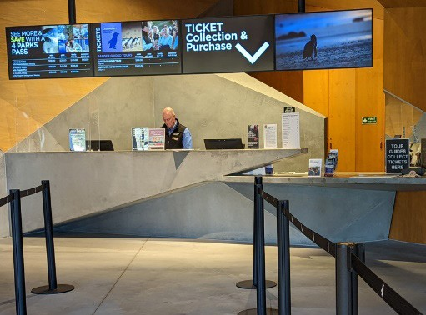
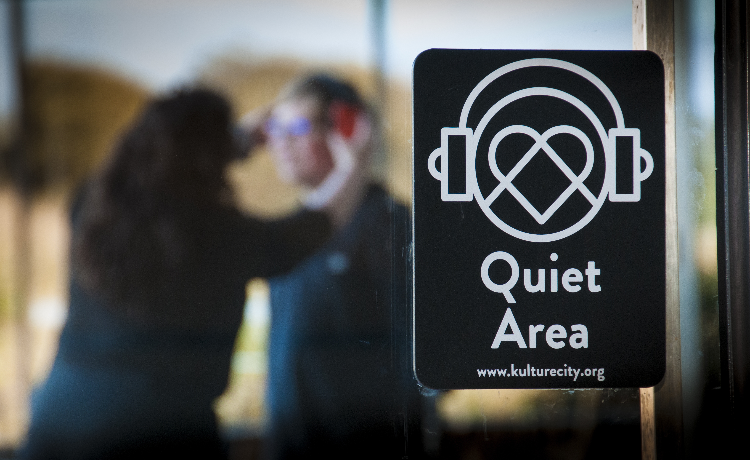

Ticketing Counter with low height section

Designated Quiet Areas Ticket counter at accessible heights
An assisted listening service is available in the Theatre. Receivers are available at no cost. Ask staff at the ticketing counter when you arrive.
For visitors with sensory needs, sensory bags are available, equipped with noise-cancelling headphones, fidget tools and verbal cue cards. Weighted lap pads are also available.
These are available for free by leaving ID with staff at the visitor centre.
In the event of evacuation trained team members will direct guests toward the safest exit points.

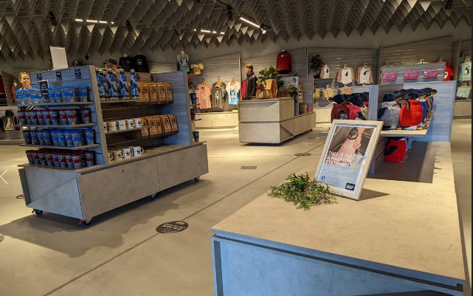
Wide spaces between display in Souvenir Shop
The souvenir shops are well laid out with wide aisles and most stock within easy reach.

Accessible Toilets and Changing Places
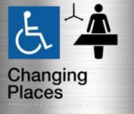
There are multiple unisex accessible toilets outside the entrance and inside the visitor centre.
There is a Changing Places facility inside the visitor centre. This includes:
- height adjustable adult sized change table
- constant charging ceiling track hoist system
- centrally located peninsula toilet
- circulation spaces as defined in the design specifications
- an automatic door with a clear opening of 950 mm at a minimum (1100 mm for beach and lake locations)
- a privacy screen
There are male and female ambulant toilets inside the visitor centre. There are toilets located midway to the penguin viewing area, although they are not accessible.
Dining
There are two options for eateries in the visitor centre. They are the Chicks Café or the Shearwater Restaurant. Opening hours for the café and restaurant vary throughout the year. Order your food from the counter and you will be given a buzzer to let you know when it is ready. Vegetarian and gluten free options are available. There is a range of seating in both areas. Some seating has views to the outside. Chairs are easily moved to allow wheelchair access.
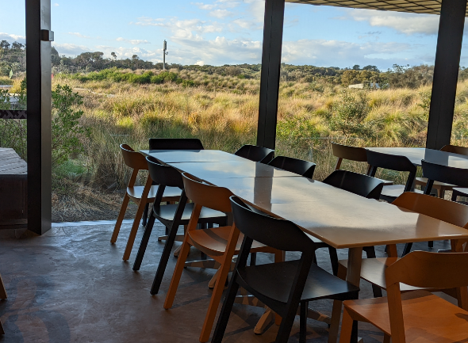
Chicks Café

The Habitat
It is an interactive area with educational opportunities where you can learn about penguins, their neighbours and the environment they live in. Pictures below.
This area can get a little loud too, so it’s also listed as a Headphone Zone.
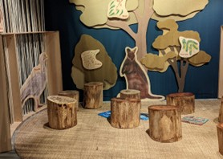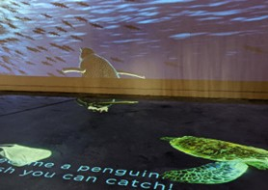
PENGUIN VIEWING EXPERIENCES
The Penguin Parade offers a variety of activities suitable for all ages and abilities. Whether you’re looking for a self-guided experience or to be led by one of our knowledgeable guides, we have an option for you. Be mindful there are some steep sections to access the viewing areas.
General Viewing - There is tiered seating in the general viewing grandstands. They overlook the picturesque Summerlands beach. The access to this area is via the boardwalks. There is allocated space at the top of the grandstand for wheelchairs with a limited number of seats. The grandstand seating is timber and concrete and there are grabrails for support to access the lower levels via the stairs. A nightly stand presentation by Visitor Experience Guides is provided and sensory bags are available from staff at this location.
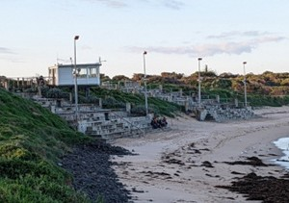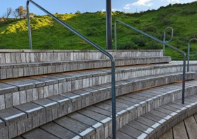
General Viewing area | Seating in the General Viewing area

Penguins Plus – This area allows for a closer viewing experience, also with tiered seating. A nightly stand talk by Visitor Experience Guides is provided.
Underground Viewing – This is an underground area where you can watch the little penguins waddle right past the window, some might even come up to the glass to say g’day. This area has ramp access, and a nightly stand talk by guides is provided.

Penguin Discovery Experience - Discover the little penguins in their natural habitat with this premium beachfront viewing experience. This fully accredited eco experience will guide you along a secluded boardwalk and immerse you within the heart of the penguin colony. Minimum age 16 years.

Ultimate Adventure Tour, Family Wildlife Tour, Penguin Guided Tour – Due to the nature of these tours, uneven ground surfaces, distance, shared personal space and viewing area requirements they are not accessibility friendly.
Some areas of the Penguin Parade can get a little loud. There are Quiet Zones and Headphone Zones around the viewing areas. They are clearly marked, but you can also ask a staff member for directions.
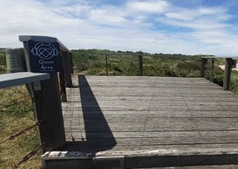 | 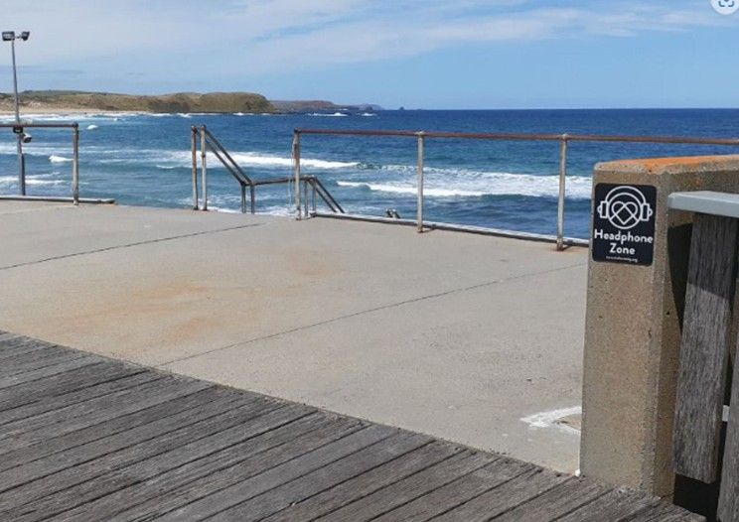
Quiet Zone Sign | Headphone Zone Sign

CONTACT

Penguin Parade
1019 Ventnor Road
Summerlands, VIC 3922
www.penguins.org.au


Communication Board

You can print and take this Communication Board with you when you visit the Penguin Parade.
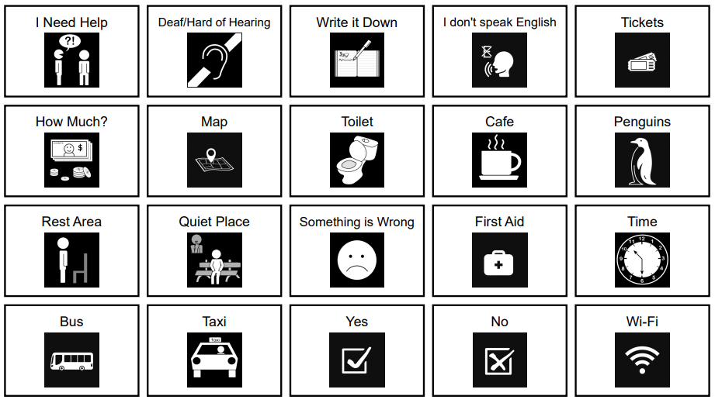
© Inclusive Tourism Pty Ltd, All Rights Reserved. 2022 Owned and developed by Inclusive Tourism Pty Ltd www.InclusiveTourism.com.au

