Phillip Island Nature Parks is committed to offering enjoyable nature-based experiences and has a range of accessible facilities available for all visitors. This following information aims to accurately describe the facilities and services that are offered at Churchill Island.
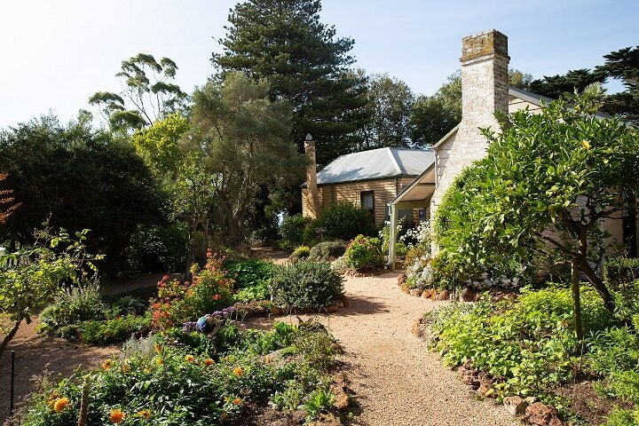
Churchill Island Heritage Farm contains a working farm, cottages dating from the 1860s and a homestead (Amess House) dating from 1872, all fully restored and open to the public.
PRE-ARRIVAL INFORMATION
A visit to Churchill Island (located off Phillip Island) calms the mind, with wide-open spaces to wander and fresh air to breathe. Explore the beautiful gardens, the historic buildings and working farm with your family and friends. Enjoy the farm animals and activities, walk the bay trails soaking in the tranquil scenery.
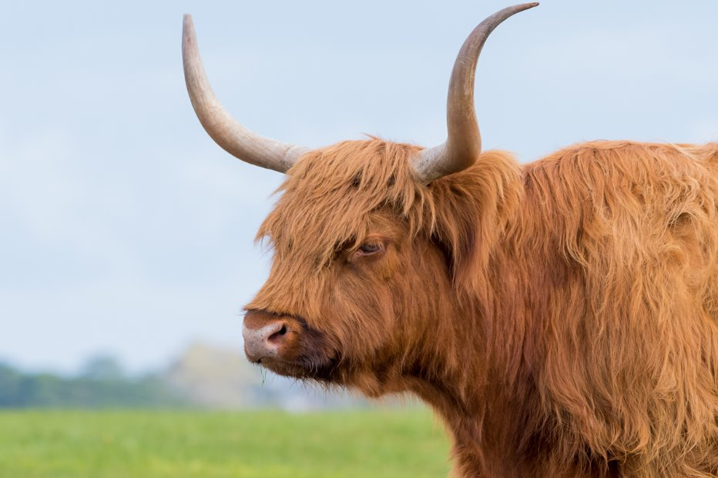
The Highland is a Scottish breed of cattle

ARRIVAL INFORMATION
Phillip Island is a 90-minute drive from Melbourne. Allow a further 10-minutes from the San Remo – Phillip Island bridge to get to Churchill Island. Follow the signs and turn right just after the Phillip Island Chocolate Factory. You will meander around a wetland until you approach a single lane bridge to access Churchill Island. Be mindful of other vehicles as you approach the bridge and ensure the bridge is vehicle free before you proceed.

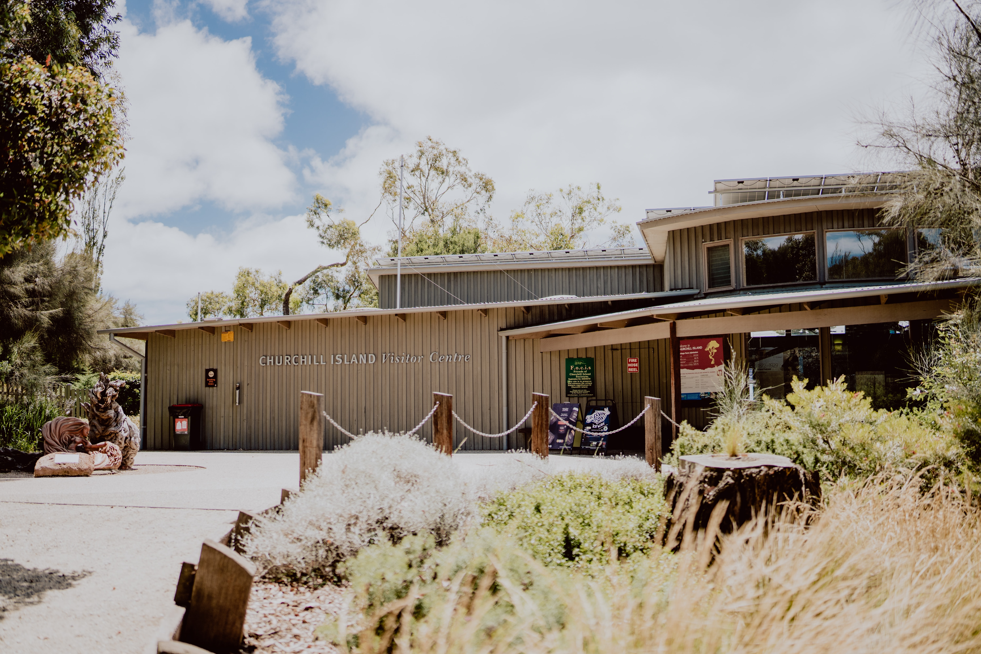
Churchill Island Visitor Centre
Carpark
- Visitors will drive over several cattle grates (safe to do so) and enter the main gate towards the Visitor Center.
- Free car parking is available on-site.
- General and accessible parking is located directly ahead of the gate entry.
- There are two accessible parking bays available, they are located nearest to the pedestrian pathway.
- A wide clear graveled walkway of approximately 40 metres leads from the car park to the Visitor Centre.
- Bus parking is located to the right of the Visitor Centre.

The Visitor Centre
The Visitor Centre main entrance is undercover with a small shelter and rest areas. Churchill Heritage Farm is a no smoking zone. Children must be supervised at all times. Assistance animals welcome but must remain on designated paths and restrained by a harness or leash.
Entry into Churchill Island Heritage Farm is through the main Visitor Centre via a manual accessible glass door, opening outward.
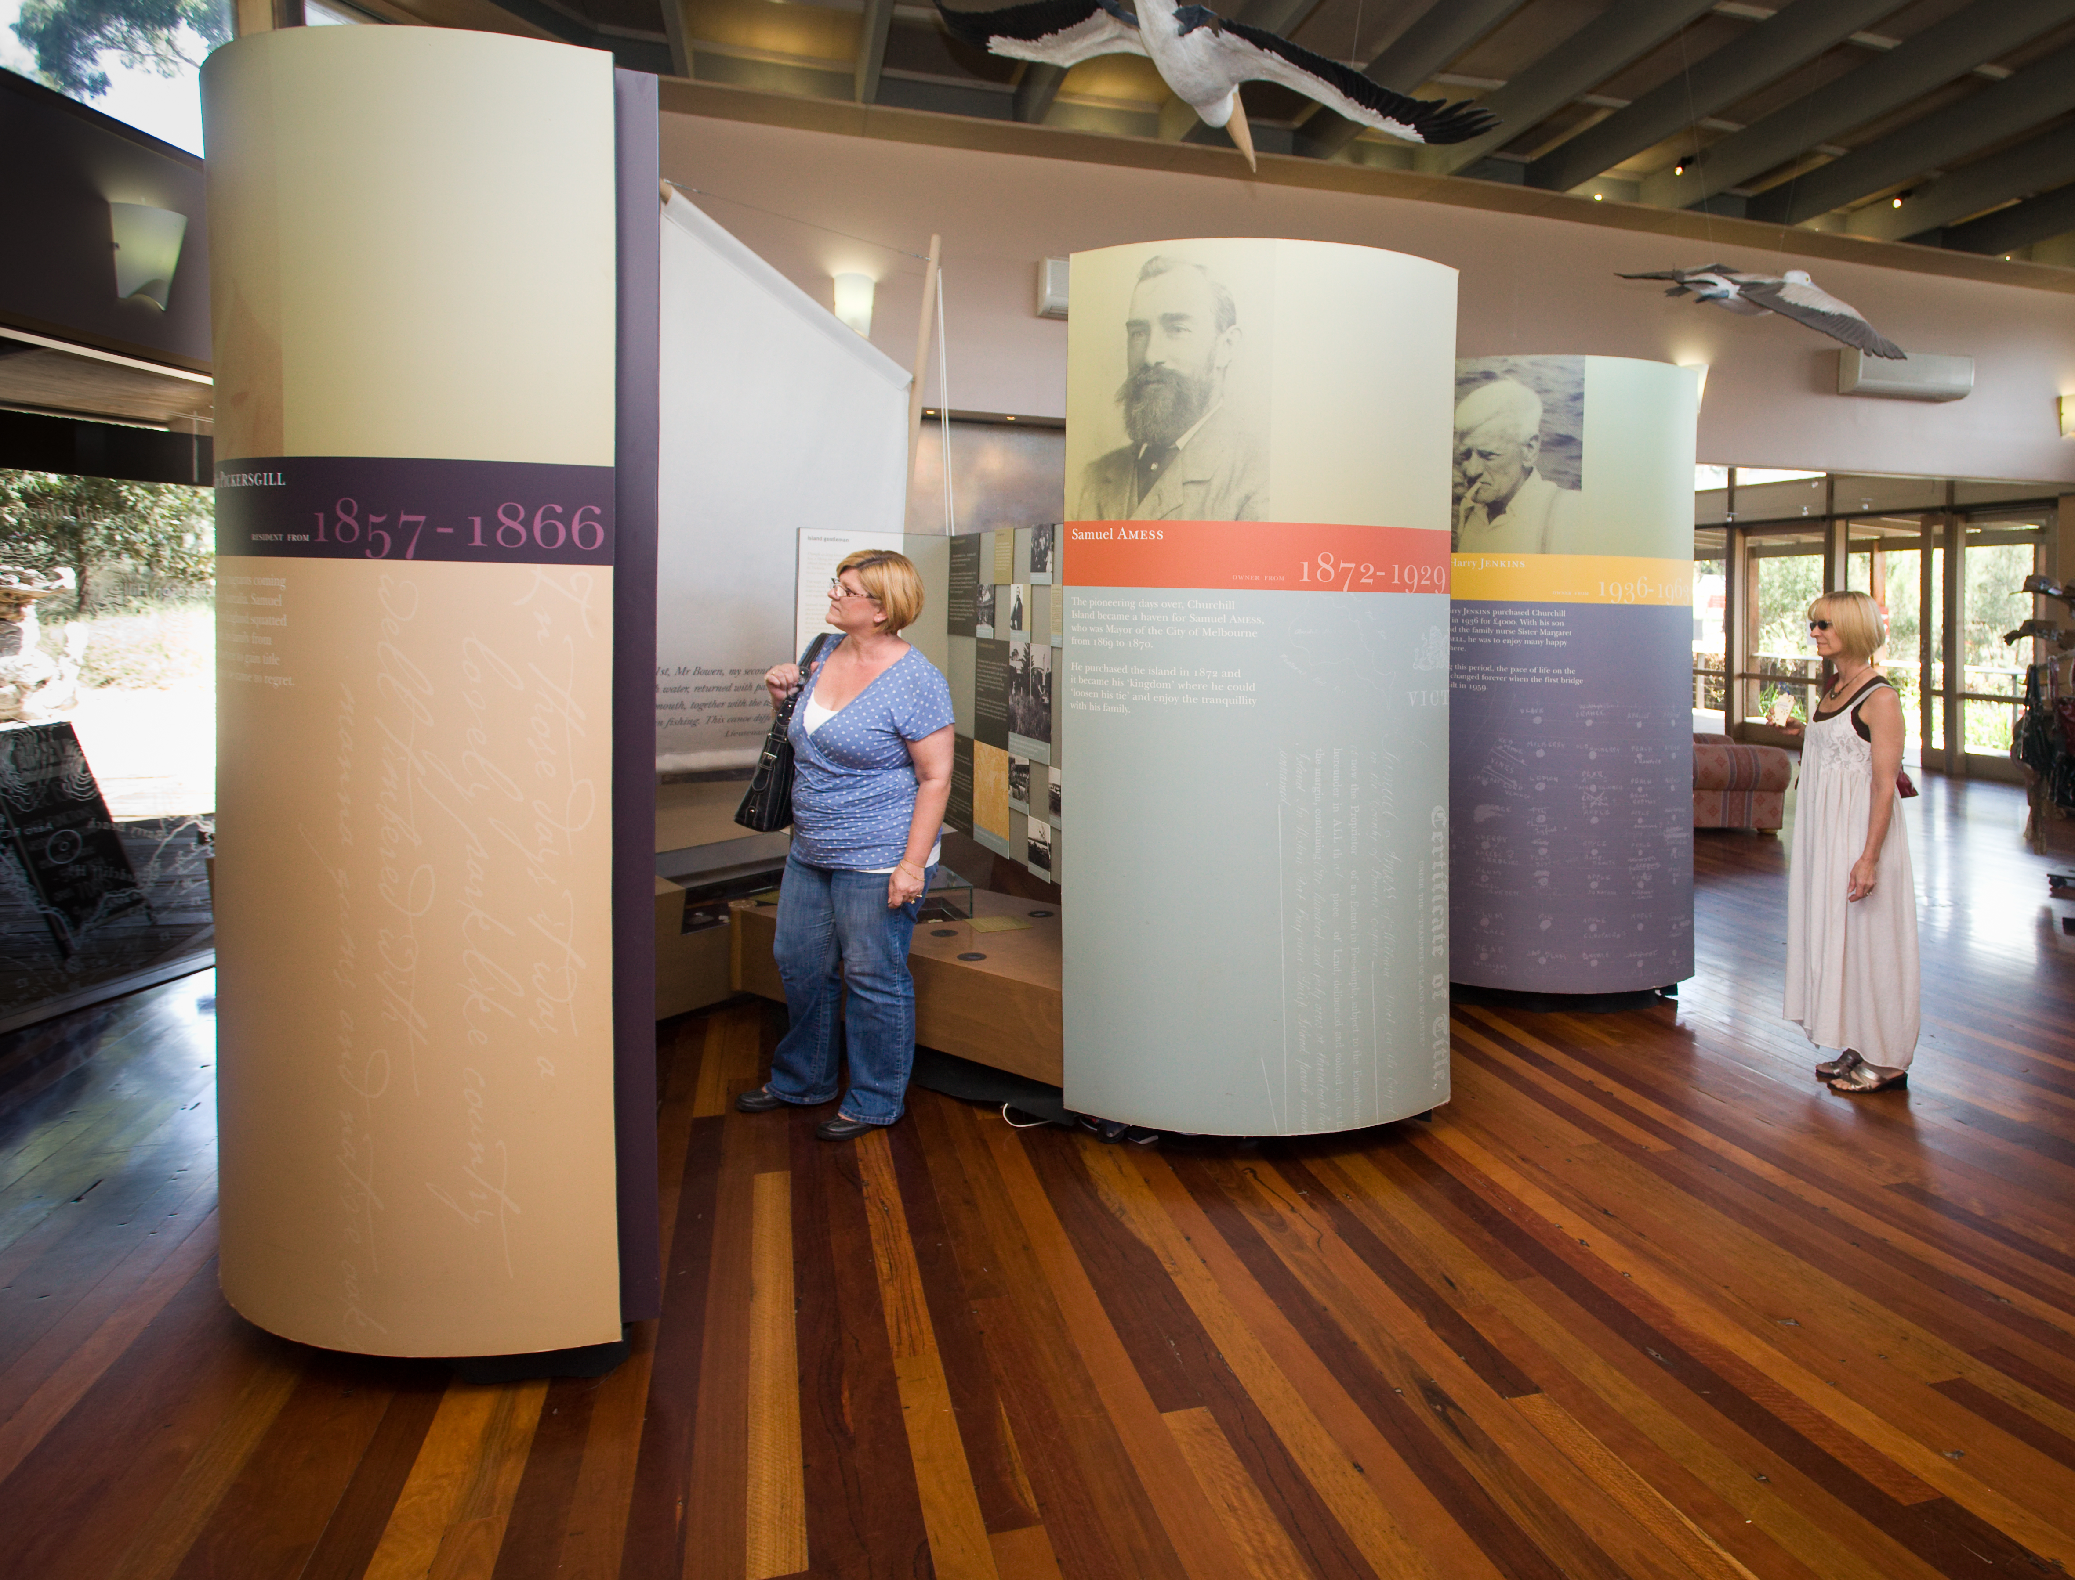
Accessible Interpretive Displays
Tickets
The ticket office is located inside the entrance to the Visitor Centre. Churchill Island is open daily, except on Christmas Day. Churchill island tickets can be purchased online here or onsite at the Churchill Island Visitor Center.
Visitors that need to purchase entry tickets, please see ticketing staff. EFTPOS only accepted. Visitors with pre-purchased tickets, please show tickets to ticketing staff upon arrival.
Please refer to our website for opening hours. https://www.penguins.org.au/attractions/churchill-island/
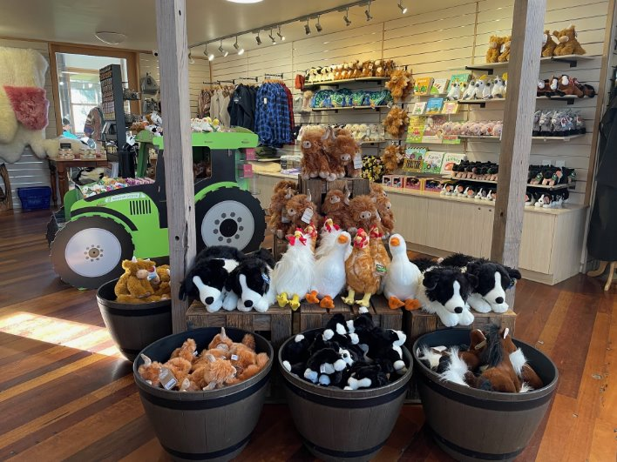
The visitor centre includes a ticketing area where you can buy souvenirs.
The Gift Shop is located in the Visitor Centre to the right of the ticket counter and is open 10am daily until closing. The Gift Shop offers a range of gifts including farm themed items, clothing and toys. Merchandise and displays are also available throughout the Visitor Centre foyer. Due to layout space, this store has limited accessibility.

Amenities  Churchill Island Heritage Farm has two sets of toilets and includes separate male and female toilets including ambulant toilet in each and a baby change facility.  Set One – Located inside the Visitor Centre.  Includes unisex accessible toilet with artificial lighting, manual door opening outward. Door clearance 810mm. Twist lock 960mm AFFL. Cubicle space 1900mm x 2400mm, grab bars to the left of toilet. Toilet seat height 450mm AFFL with left hand transfer. Sink height 800mm AFFL with lever tap 910mm AFFL  Set Two – Located in the farming activity area.  Separate male and female toilets.  Toilets have a small, raised edge at entry/exit.  The female toilets have a baby change facility. | 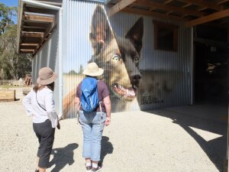  Churchill Island working dog mural
Farmhouse Cafe  - There is a Café located in the Visitor Centre, to the right of the Gift Shop.  - Entry is via a glass manual door.  - All day breakfast, lunch and light snacks are available to be ordered at the counter, with staff delivering orders to tables.  - Chairs with backrests and tables are available.  - Outside Café seating includes a wider space with chairs and backrests/armrests as well as tables. Access is via a double set of glass manual doors, opening outward.  - EFTPOS is available.  - Full menu is available until 2.30pm. Snacks and drinks are available till 3pm.  - A drinking fountain is available at the entrance to the Visitor Centre.  The Grounds  Varied terrain throughout; gravel, wooden boardwalk, shell grit, uneven brick paving, grass, asphalt; some with varied gradient.  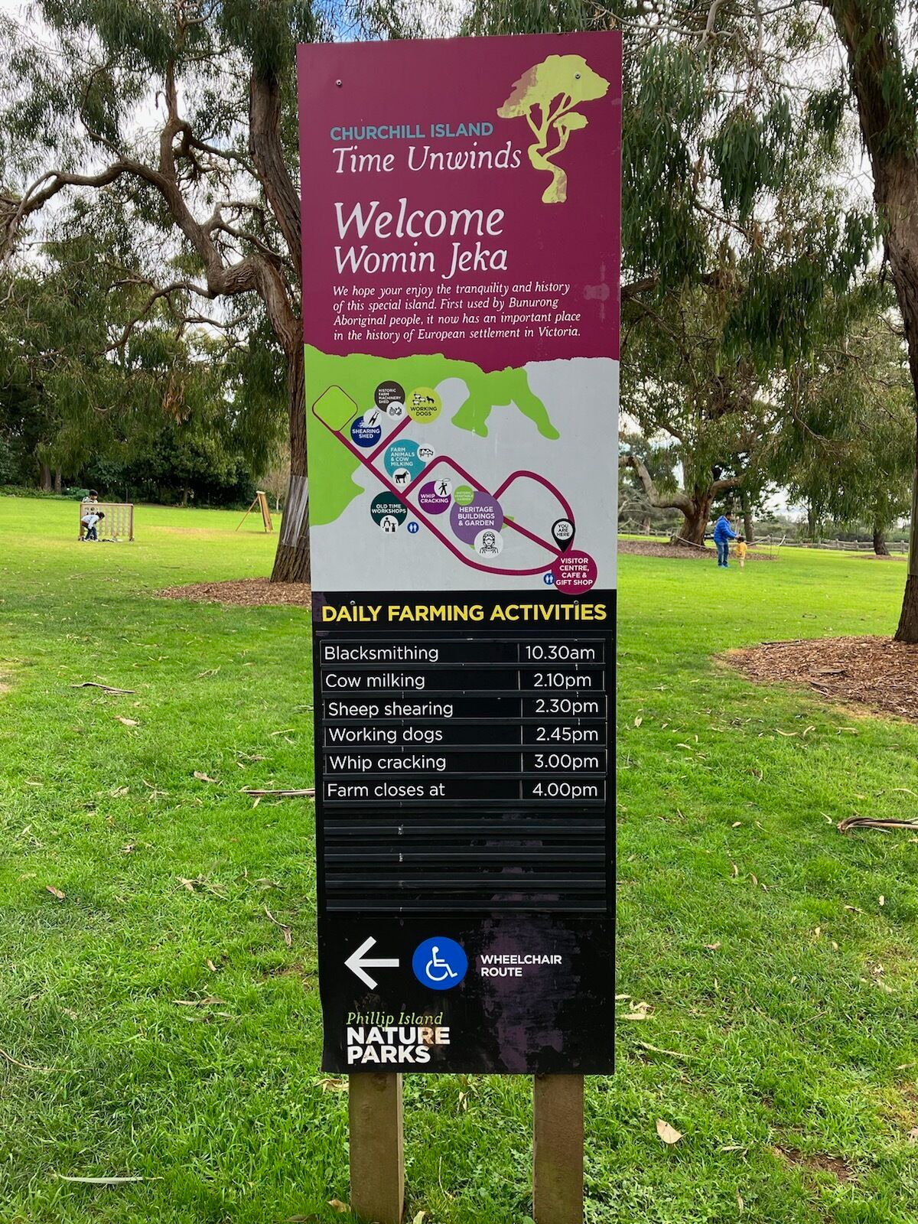  Amess House Homestead  Churchill Island’s historical homestead, Amess House, dates back to the 1850’s.  There is a shell grit pathway leading to the Homestead from the Visitor Centre.  Access to the front of the homestead is via steps with handrail. Entry is via an open wooden door.  Wheelchair access is available at the back of the Homestead.  It is via a manual door opening outward with a clearance of 800mm. | Safety – Visitor Centre  - Small raised edge at entry.  - Consistent lighting throughout.  - Obstacles (merchandise displays, bins, mats) throughout Visitor Centre foyer.  - Signage for wet floors may be displayed.  - End of wooden boardwalk outside Visitor Centre has slight decline and drainage grate.  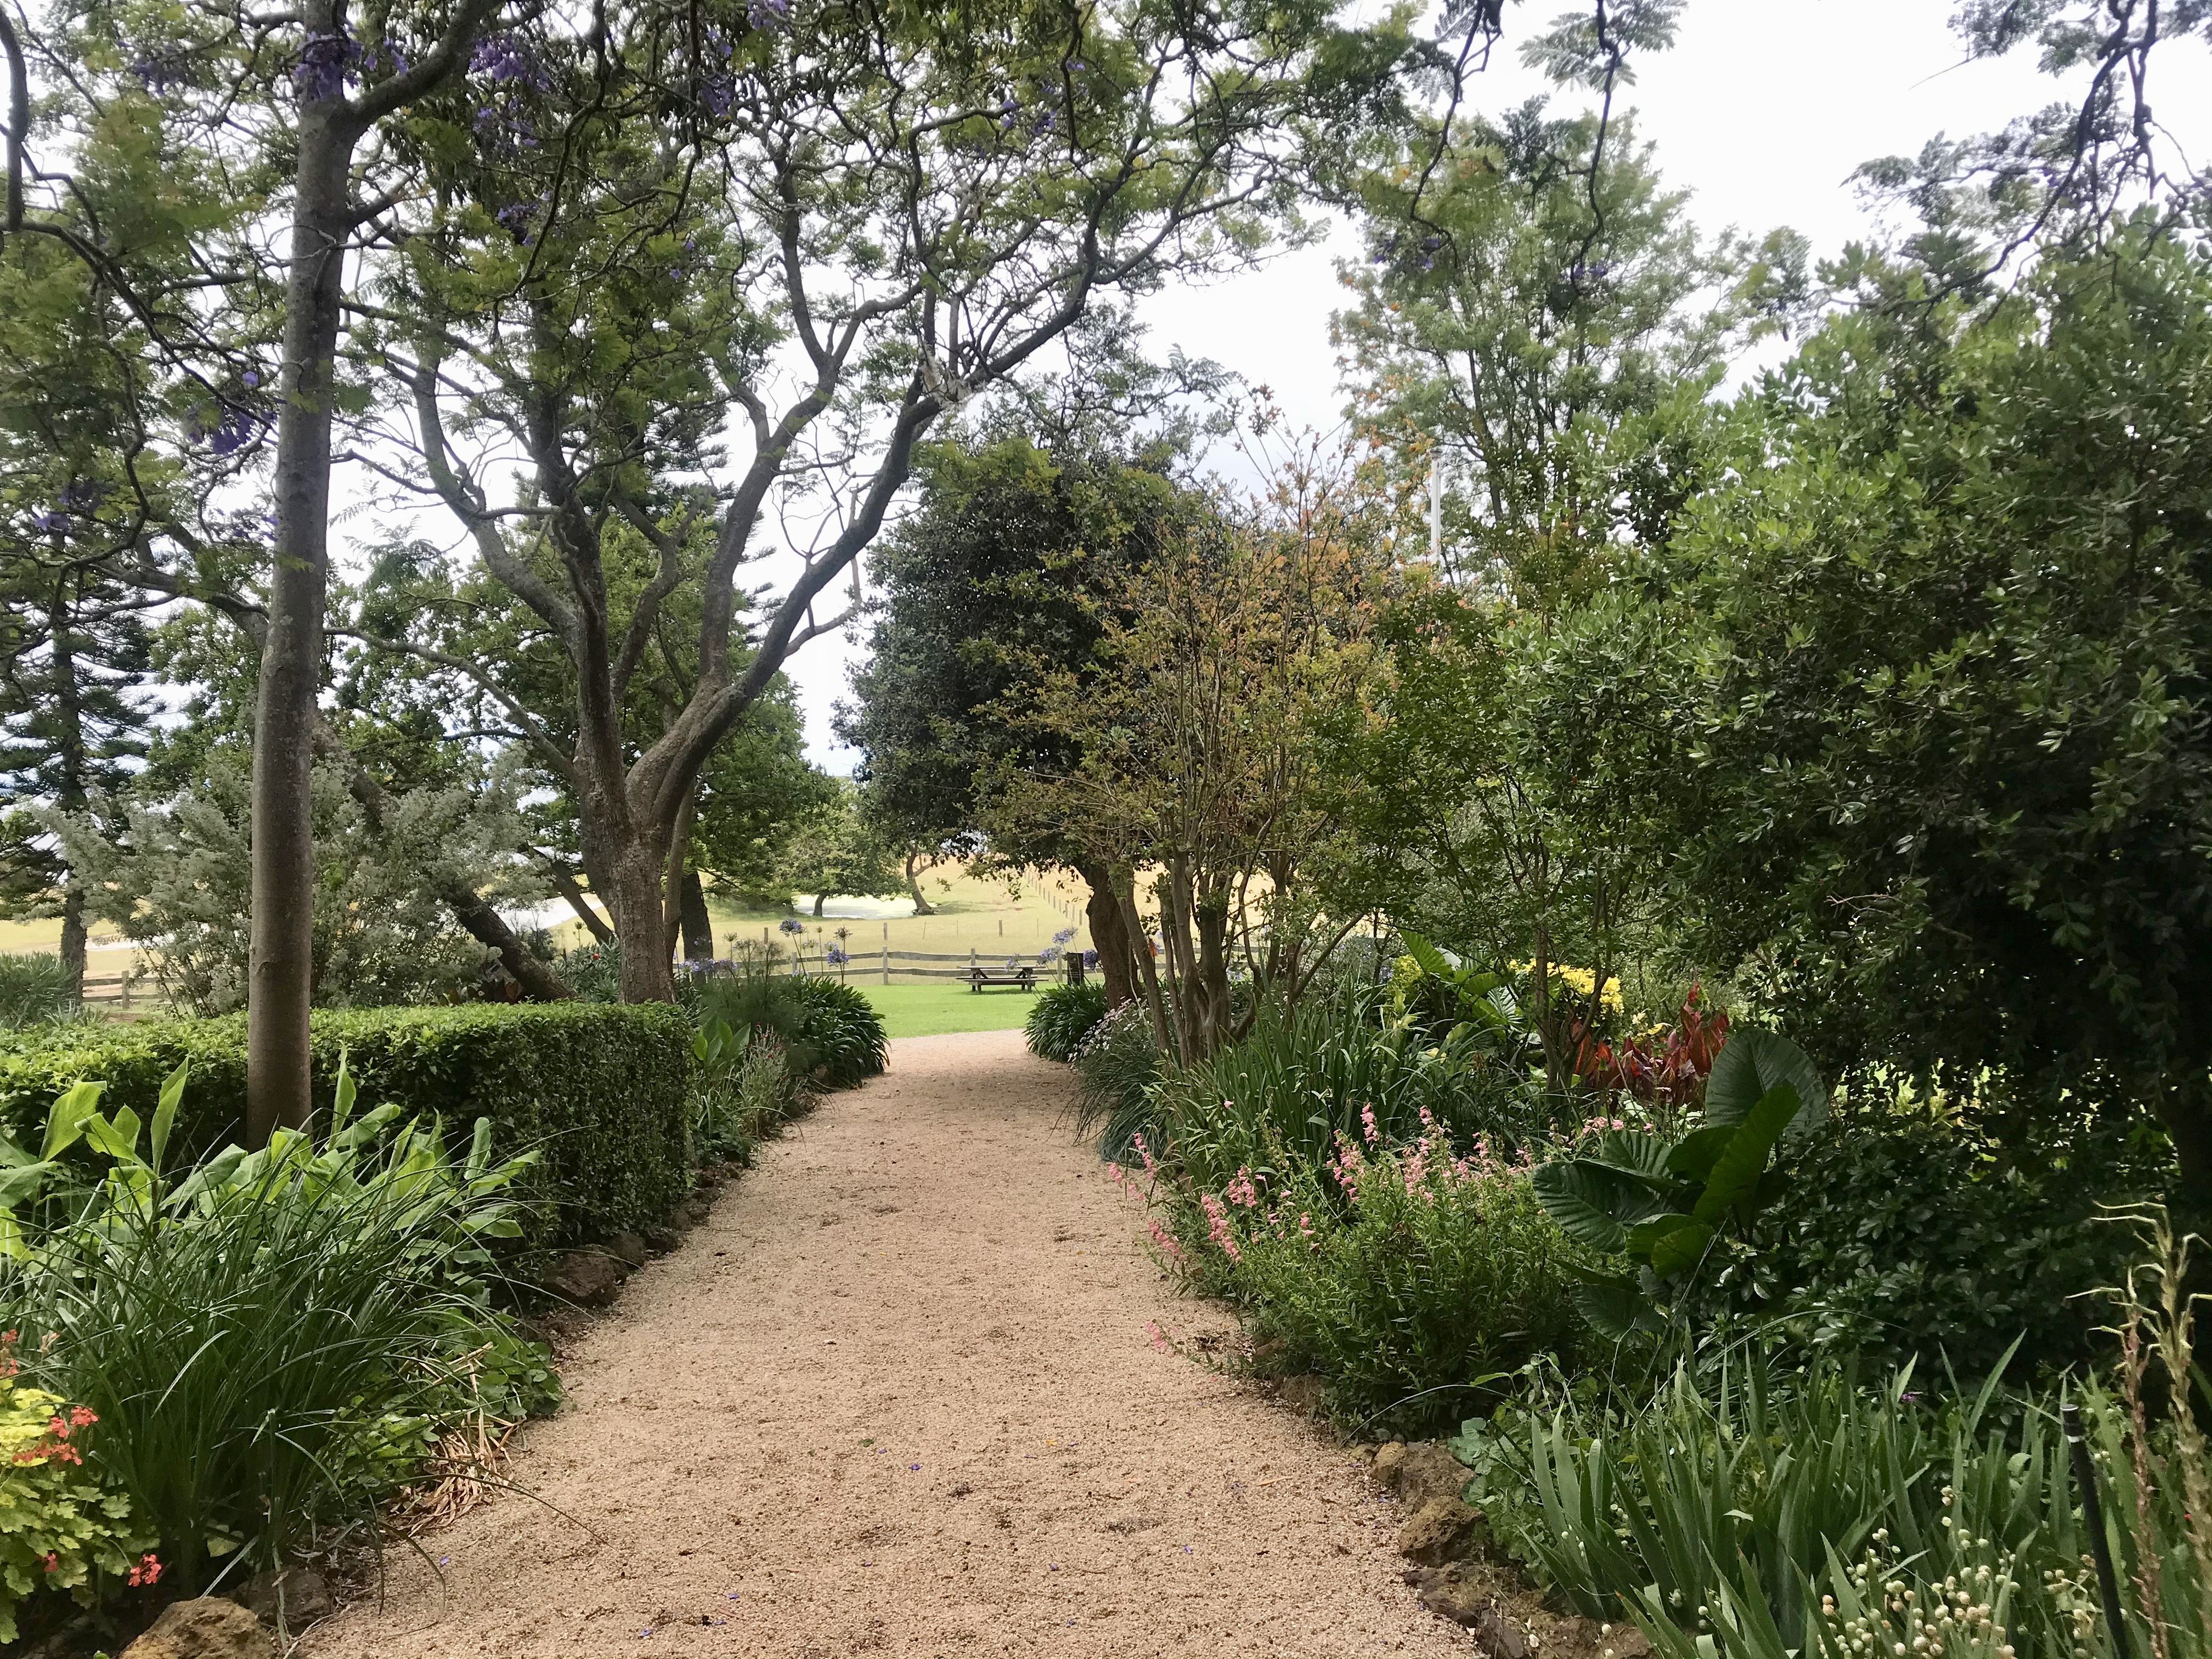  Churchill Island Heritage Farm is the site of the first European garden in Victoria  Safety - Amess House Homestead  - Uneven pathways.  - Front Cottage veranda raised above ground level.  - Due to the historical nature of structures, wheelchair access maybe limited.  - Front cottage access steps with handrail.  - Furniture placed on Cottage veranda.  - Door mats placed on ground at entry/exits.  - Rug in Cottage hallway.  - Dulled lighting throughout.  - Low head clearances.
Farming Activities
Churchill Island offers a range of daily farming activities.
Daily farming activities include;
- Cow milking
- Blacksmithing
- Sheep shearing
- Wagon rides (only on weekends, school holidays and public holidays at an additional cost)
- Meet the working dogs
- Whip cracking
Please refer to our website for activities schedule.
Churchill Island activities
To access the farming activities;
Exit the Visitor Centre via a manual accessible glass sliding door located to the left of the Gift Shop.
Follow the wooden boardwalk to the left followed by a 115-metre shell grit pathway up a hill to the farming sheds. Wayfinding signage is available along the pathway. Pram parking at the all farming activity stations (please note, prams cannot access the tiered seating stand in Shearing Shed).
Exclusive accessible access viewing areas at all farming activities.
Cow Milking
Cow Milking is located at the horse stables.
Line up at the milking station which is located outside the horse stables.
Visitors sit on small milking stool to milk a cow. A farmer will be there to provide instructions and to help visitors.
Sheep Shearing
Sheep Shearing is located in the Shearing Shed. Visitors enter the Shearing Shed via open accessible entry ways. There are two entry/exit points located on either side of the shed.

Visitors to sit in tiered seating stands. There is no allocated seating. A farmer will give an audio information presentation on the history of Australian sheep shearing and shearing equipment.

The presentation also includes a sheep shearing demonstration. Shearing does not harm the sheep and is an annual requirement for the wellbeing of the animal. At the end of the demonstration, the farmer will be available to answer questions.

Whip cracking
Whip Cracking takes place daily on the lawn opposite the Blacksmith Shop.

Visitors make a semi-circle around the outside of the lawn. Visitors remain off the grass and stand on the pathway, taking care to remain within a safe distance from the whips.

A farmer gives an audio information presentation on the history of Australian whip cracking and equipment. The presentation also includes a whip cracking demonstration.

Visitors have opportunity to use the whips under the guidance of the farmer. At the end of the demonstration, the farmer is available to answer questions.
Working dogs
This activity has a moderate grassy gradient to viewing area. Visitors line up at the fence perimeter to view the activity.

A farmer enters the paddock of sheep with a working dog and gives an amplified audio information presentation on the history of Australian working dogs.

This presentation also includes a working dog demonstration of rounding up sheep. At the end of the demonstration the farmer is available to answer questions.

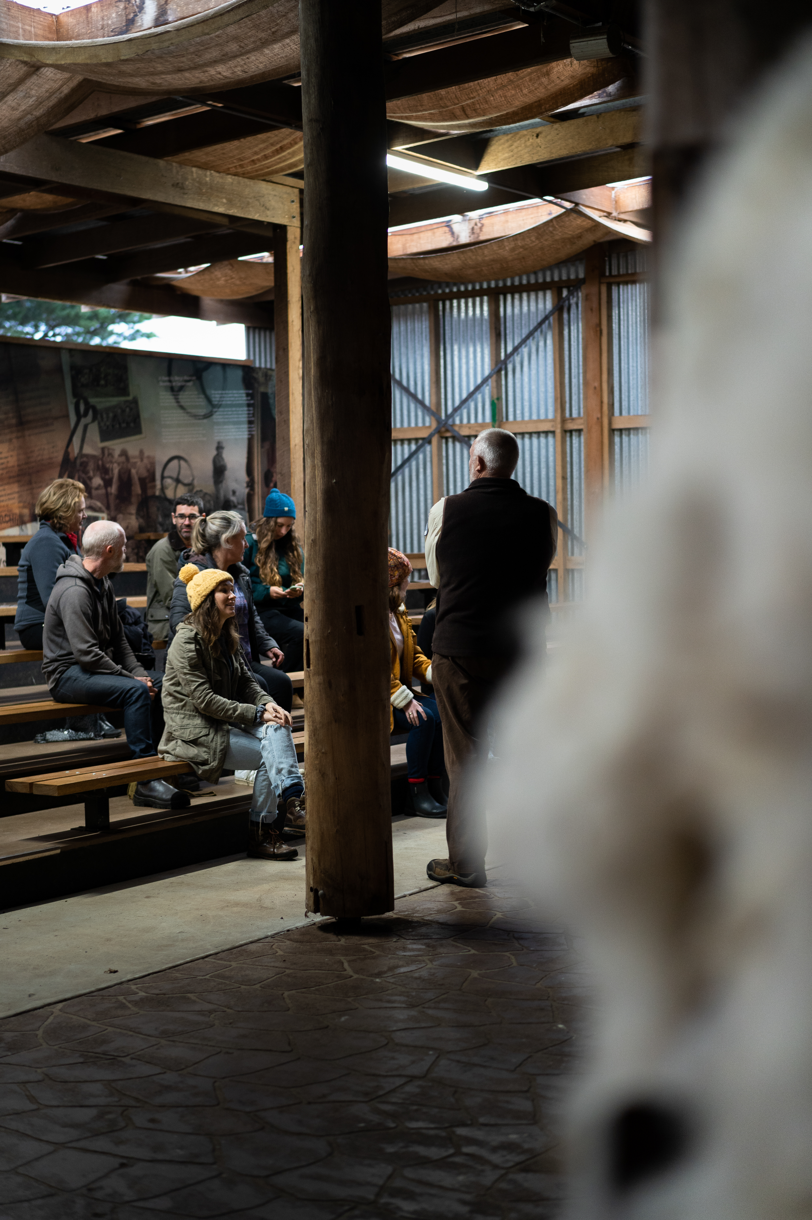
Churchill Island Shearing Shed

Safety – Farming Activities
Cow Milking and Horse Stables
- Small, raised edge to paved milking area.
- Dulled lighting in horse stables.
- Uneven and inward slope fall of paved area in horse stables.
- Farming equipment displayed on walls throughout horse stables.

Shearing Shed
- Small raised edge at entry/exit.
- Wooden pillars throughout.
- No handrails on tiered seating.
- No tactile ground surface indicators prior to tiered seating steps.
- Non-slip edges installed on step edges.
- Stage with raised edge and roped barrier.

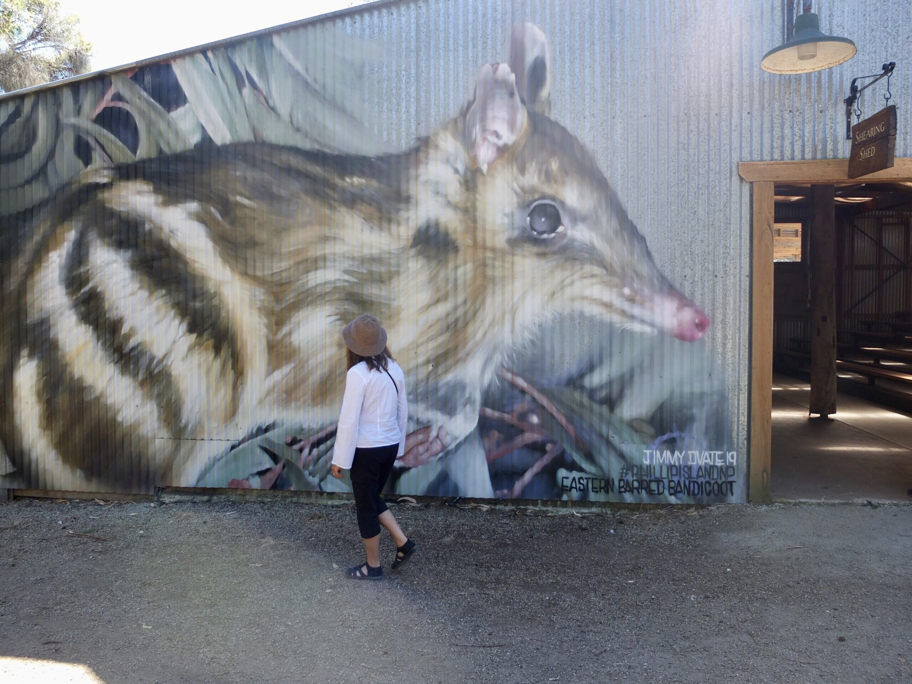
Eastern Barred Bandicoot mural at the Shearing Shed

First Aid
If first aid is required, see a staff member.
Defibrillator available for use located in the Visitor Centre. Please see ticketing staff.
In the event of an emergency, staff are on hand to assist with any evacuation requirements (including the provision of audible fire alarms, fire wardens, accessible and hazard free emergency exits and assembly areas on accessible routes).

More Information
Follow Phillip Island Nature Parks on Facebook or Instagram.
https://www.facebook.com/churchillisland/ https://www.instagram.com/phillipislandnp/

Contacts
246 Samuel Amess Drive
Churchill Island Newhaven 3925
03 5951 2800
www.penguins.org.au

Sensory Guide
We are a certified sensory-inclusive site with professionally trained staff. Sensory bags are available, equipped with noise-cancelling headphones, fidget tools and verbal cue cards. Weighted lap pads are available. The bags and lap pads can be checked out for free by leaving an ID with our staff.
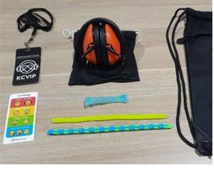
While at Churchill Island you may experience:
Feel | Sounds | Sights | Smells
Churchill Island Toilets
Shared personal space  Different ground surfaces | Toilet flushing  People  Water running | Bright lights  Glare  Mirror/Reflection | Disinfectants  Air freshener
Amess House Homestead
Different ground surfaces  Shared personal space  Weather | Animals  Creaking doors  Flying insects  Footsteps | Dim lighting  Flying insects  Glare | Animals  Flowers  Mustiness
Cow Milking/Working Dogs
Change in gradients  Different ground surfaces  Shared personal space  Wind | Animals  Audio presentation  People  Running water | Dim stable lighting  Glare | Animals  Hay  Nature
Sheep Shearing
Different ground surfaces  Shared personal space | Animals  Audio presentation  Shears clicking/buzzing  Echo  Footsteps/People | Animals being shorn  Dim lighting | Animals  Hay  Nature
Whip Cracking
Different ground surfaces  Shared personal space  Weather | Audio presentation  People  Whip cracking | Lashing whip display  Glare | Animals  Flowers

Communication Board

You can print and take this Communication Board with you when you visit the Penguin Parade.
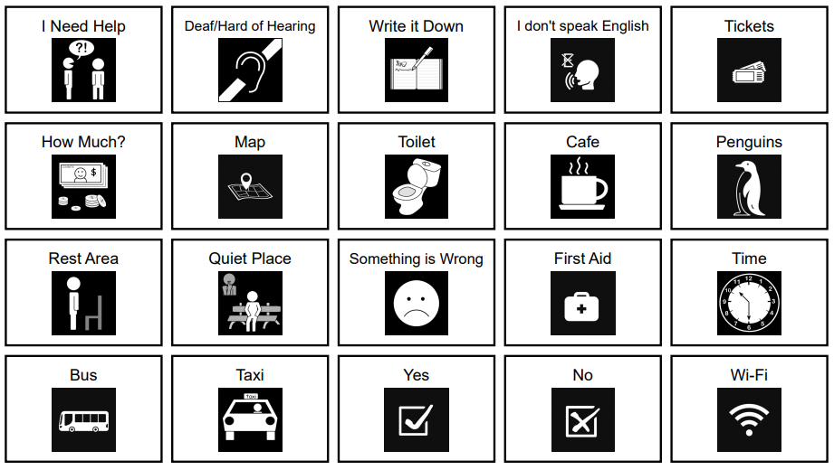
© Inclusive Tourism Pty Ltd, All Rights Reserved. 2022 Owned and developed by Inclusive Tourism Pty Ltd www.InclusiveTourism.com.au

